"Directed Diorama”
Exhibition Date: August 4 – August 30, 2016
Opening Reception: Thursday, August 4, 6 – 8pm

Into the Small Yet Immense World of Sung Soo Kim
by Jiyeon Jung, Curator

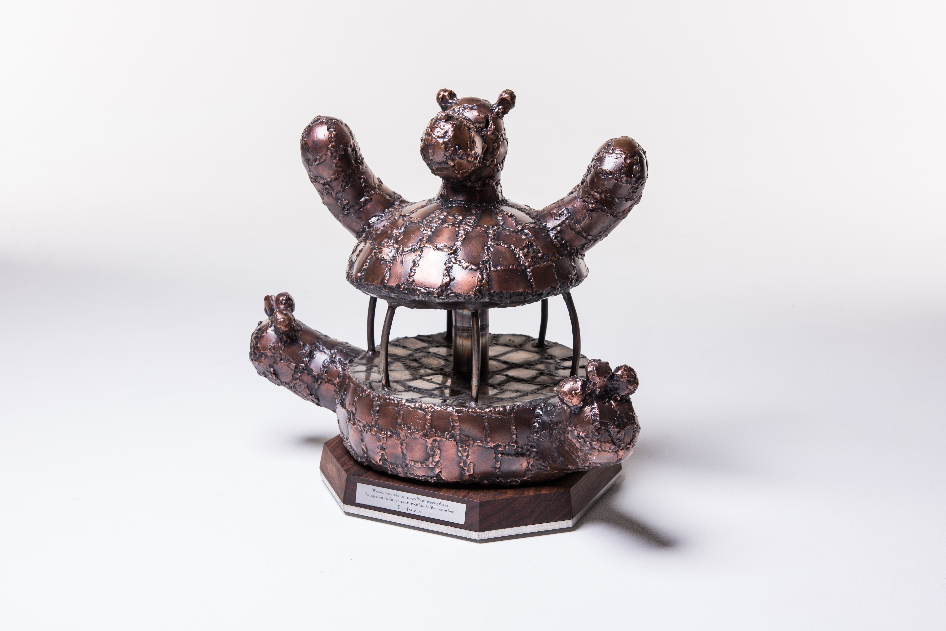
Sung Soo Kim is an artist with refined craftsmanship and whimsical imagination. In this exhibition, Kim presents his recent work, Diorama Series, and related drawings and videos showing the work-in-progress scenes.

Kim unfolded his childhood memories and created a miniature world where his never-ending story could live. This spectacular installation draws viewers into the huge chess-like world on a grand stage. This consists of a number of small individual sculptures including bears, turtles, girls, boys, soldiers, and so on. Traditionally, the diorama is used as an educational tool and fascinates museum-goers because with its familiarity and strangeness. Kim does not try to elevate the diorama tradition. He is more interested in transforming his fictional world, reminiscent of his old toys, into an anecdote about our competitive and distressed life.

Overall, it is constructed as battle scene between animals and humans. However, upon further inspection, the viewer will find that it is not a war between different groups: figures are not pointing their weapons at each other but marching toward the center to reach to the top of the mountain. At this mountaintop there are humans and animals cheering side by side, collectively celebrating this accomplishment.

Kim's harmonious worldview embraces the difficulties of modern living in an oversaturated and demanding society. Ideally we are granted life in order to grow into a higher self- an eternal, conscious and sincere being- however, we too often forget why we are on this long journey. It may feel like a lonely fight where anybody who gets in the way is recognized as an enemy. Kim invites viewers to look at the life through this childhood-dream world to remind us that we are in this together.

ABOUT THE ARTIST
Born in 1984 in Jeonju, South Korea, Sung Soo Kim received BA, MFA, and PhD in Fine Arts from Chonbuk National University in Jeonju, South Korea where he lives and works. He focuses on preserving and visualizing the childhood memories. He uses images of animals, fairy tales, amusement parks, which influenced his art. Recently, he has been expanding to other genres and created large-scale installations, Diorama Series, and drawings.
He has had solo exhibitions and over eighty group exhibitions in Jeonju, Seoul, and New York including Samsung Raemian Gallery, Seoul, Gana Insa Art Center, Seoul, Gyodong Art Museum, Jeonju. He is the recipient of the Selected Artist Prize, 37th Joongang Fine Arts; the Selected Artist, the 2nd POSCO Art Museum; Winner, the 2nd Asia Modern Art Prize; Young Selected Artist, the 4thGyodong Art; Winner, the 46thJoellabukdo Fine Arts Prize; Selected Artist, the 58thWoojin Culture Foundation. Currently he is a member of C. Art, Joellabuko Emerging Artist Group.

